Participant Information
Name:______________________________ Date of Birth:____________ Phone number:_________________
Address: ____________________________________ Email:________________________________________

Check group(s) you are registering for:
Groups: Children, Teens, Emerging Adult | Group Leader | Cost & session Info
☐ Adolescent DBT (12 – 18 years old): 8 sessions  Introduction to skills | Ashley, LAMFT  Ana, Intern  Online  TBD – reach out for info | $350 ($60 single session rate)  60 minutes per week/8weeks  Wednesdays 5:00pm – 6:00pm
☐ Early Adult DBT (18-25 years old):  8 sessions  Introduction and review of skills | Emily, LAMFT-T, LAC-T  Online  TBD – reach out for info | $350 ($60 single session rate)  60 minutes per week/8 weeks  Thursdays 5:30pm – 6:30pm
Groups: Adults | Group Leader | Cost & session Info
☐Adult Level 1: Beginner  8 sessions  Introduction to Distress Tolerance | Bradley, LAMFT  Online  Starting July 30th, 2025 | $350  ($60 single session rate)  90 minutes per week  Wednesdays 5:30 – 7:00pm
☐Adult Level 2: Advanced  6 sessions  Review of skills | Ashley, LAMFT  Emily, LAMFT-T, LAC-T  Online  Starting August 12th, 2025 | $325  ($60 single session rate)  90 minutes bi-weekly  Tuesdays 6:00 – 7:30pm
☐Family Recalibration  5 sessions | Ashley, LAMFT  Ana, intern  Online  TBD – reach out for info | $275  ($60 single session rate)  60 minutes per week  Thursdays 1:00-2:00pm
Signature:

If you do not already have a credit card on file, please complete this form with your registration.

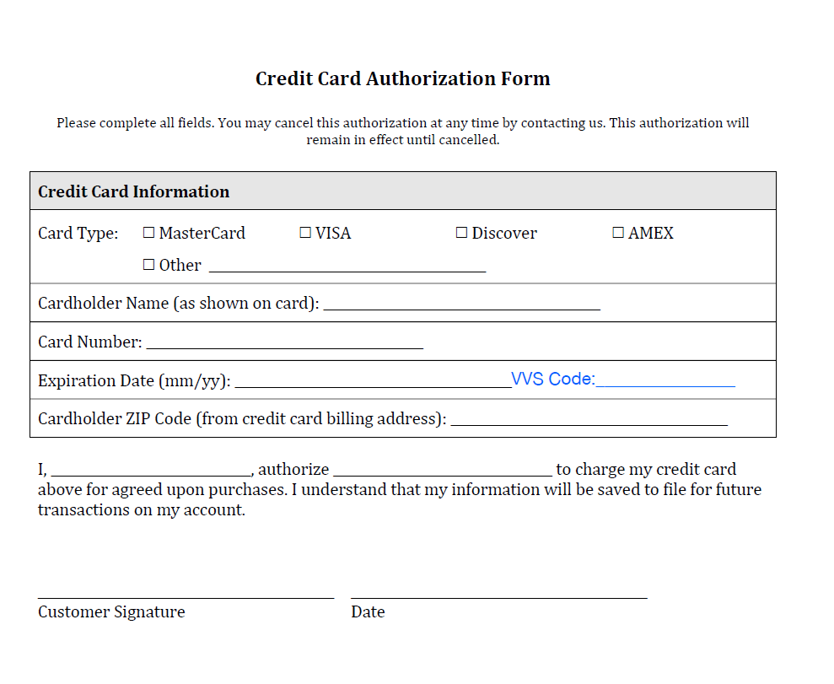
Email associated with owner of this card: ______________________________________

