Participant Information
Name:___________________________ Address: _________________________________________
Date of Birth:__________ Phone number:________________ Email:_________________________

Group(s) you are registering for:
Groups: Children, Teens, Emerging Adult | Group Leader | 8-week sessions
☐ Adolescent DBT (13 – 17 years old)  Introduction to Distress Tolerance, Emotional Regulation, and Interpersonal Effectiveness.  Name of participant:  Age: | Ashley  Online  May 17 – Jul 5 2023 | $250  60 minutes per week/8weeks  Wednesdays 3 - 4pm
Groups: Adults | Group Leader | 8-week sessions
☐ Adult Level 1  Introduction to Distress Tolerance, Emotional Regulation, and Interpersonal Effectiveness.  Name of participant: | Bradley  Online  Starting May 3rd | $45 drop in rate, $30/session for 4+ session commitment  Open Group  90 minutes per week  Wednesdays  5:30 – 7:00pm
☐ Adult Level 1  Introduction to Distress Tolerance, Emotional Regulation, and Interpersonal Effectiveness.  Name of participant: | Tara  Online  Starting May 1st | $45 drop in rate, $30/session for 4+ session commitment  Open Group  90 minutes per week  Mondays 6 – 7:30pm
☐Adult Level 2  Participant has completed all three of Level 1 groups at least one time.  Name of participant: | Ashley  Online  May 3 – Jun 21 2023 | $250  90 minutes per week/8weeks  Wednesdays  6 – 7:30pm
Total Cost: ________________

Signature of Client (or responsible party if client is a minor) Date
If you do not already have a credit card on file, please complete this form with your registration.
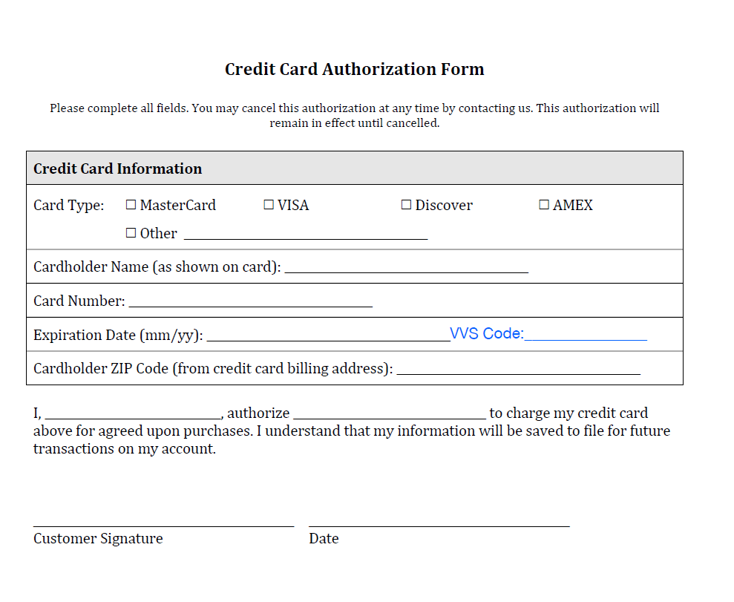

Email that is associated with the owner of this credit card:

__________________________________________

